CSC6033 – Week 3

Exercise E#3 Submission
Finite State Automaton for Validating Exactly 30¢ Using US Coins (1¢, 5¢, 10¢, 25¢)

1. Formal Definition
M = (Q, Σ, δ, q₀, F)
Σ (Alphabet): {1, 5, 10, 25} (Penny = 1¢, Nickel = 5¢, Dime = 10¢, Quarter = 25¢)
Q (States): {q₀, q₁, …, q₃₀, q_dead} where qᵢ encodes the running total i cents
q₀: Initial state (0¢)
F: Final states {q₃₀} (accepting state)
δ (Transition Function): For any qᵢ and coin c ∈ {1, 5, 10, 25}, δ(qᵢ, c) = q_{i+c} if i + c ≤ 30; otherwise δ(qᵢ, c) = q_dead. From q₃₀, any coin → q_dead. From q_dead, all coins loop to q_dead.

2. Transition Rule Explanation
Add each coin value to the current total. If the sum exceeds 30¢ or any coin arrives after reaching 30¢, the machine transitions to q_dead and stays there. The word (coin sequence) is accepted if and only if the machine ends in q₃₀.

FSA Diagram:

Figure 1. FSA for exactly 30¢ with US coins {1, 5, 10, 25}. Start at q₀. Accept at q₃₀ (double circle). Rule: From qᵢ, coin c → q_{i+c} if i+c ≤ 30; else q_dead. From q₃₀, any coin → q_dead. The dead state self-loops on all inputs.

3. FSA Diagram
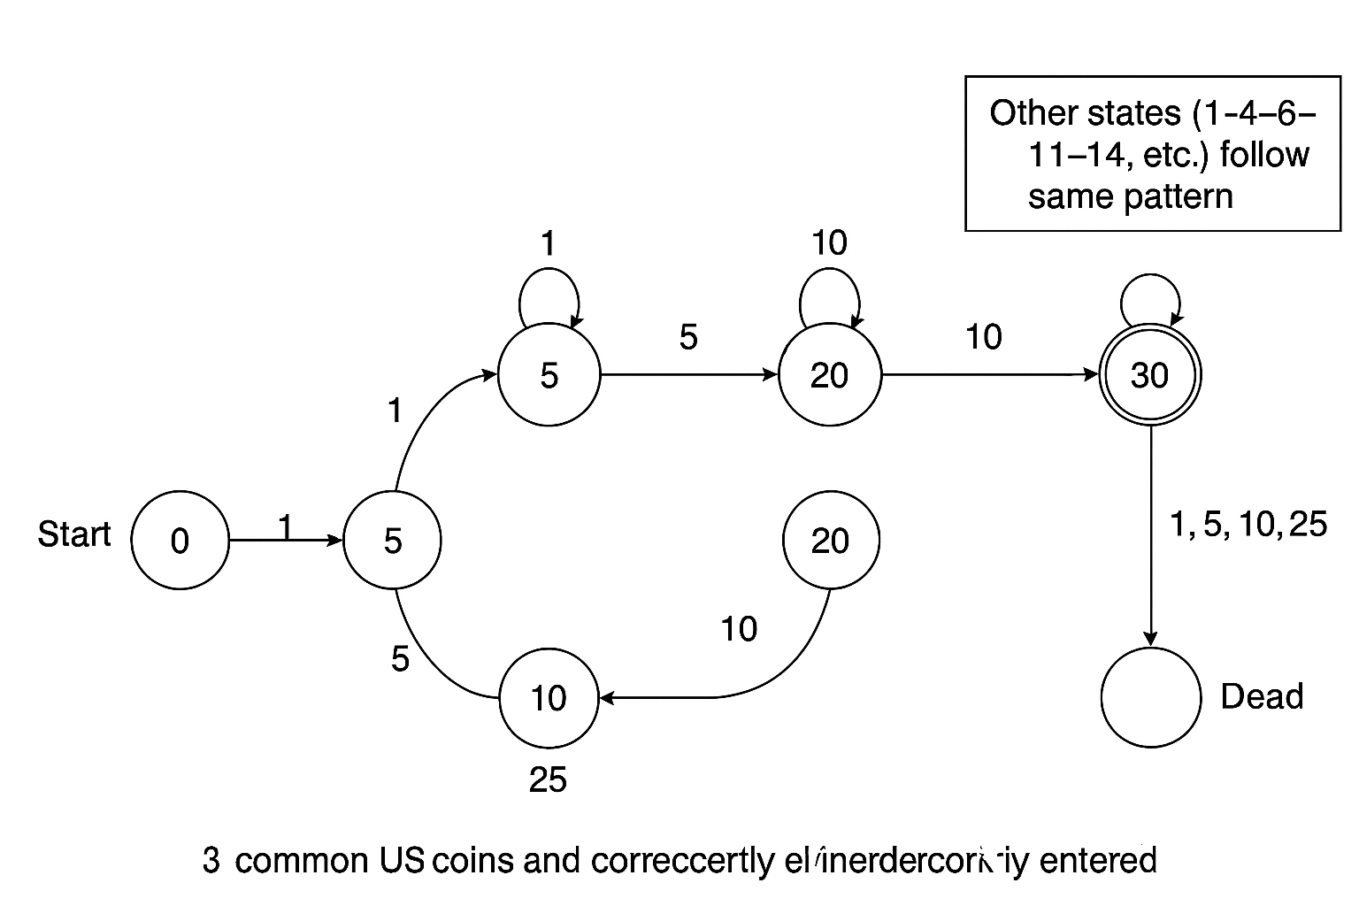
Figure 1. FSA for exactly 30¢ with US coins {1, 5, 10, 25}. Start at q₀. Accept at q₃₀ (double circle). Rule: From qᵢ, coin c → q_{i+c} if i+c ≤ 30; else q_dead. From q₃₀, any coin → q_dead. The dead state self-loops on all inputs.

4. Examples
10, 10, 10 → q₀ → q₁₀ → q₂₀ → q₃₀ (Accept)
25, 5 → q₀ → q₂₅ → q₃₀ (Accept)
10, 25 → q₀ → q₁₀ → q_dead (Reject, 35 > 30)
25, 5, 1 → q₀ → q₂₅ → q₃₀ → q_dead (Reject, extra coin after 30)

Appendix A: Full Transition Table (δ)
From State | Coin | To State
q0 | 1 | q1
q0 | 5 | q5
q0 | 10 | q10
q0 | 25 | q25
q1 | 1 | q2
q1 | 5 | q6
q1 | 10 | q11
q1 | 25 | q26
q2 | 1 | q3
q2 | 5 | q7
q2 | 10 | q12
q2 | 25 | q27
q3 | 1 | q4
q3 | 5 | q8
q3 | 10 | q13
q3 | 25 | q28
q4 | 1 | q5
q4 | 5 | q9
q4 | 10 | q14
q4 | 25 | q29
q5 | 1 | q6
q5 | 5 | q10
q5 | 10 | q15
q5 | 25 | q30
q6 | 1 | q7
q6 | 5 | q11
q6 | 10 | q16
q6 | 25 | q_dead
q7 | 1 | q8
q7 | 5 | q12
q7 | 10 | q17
q7 | 25 | q_dead
q8 | 1 | q9
q8 | 5 | q13
q8 | 10 | q18
q8 | 25 | q_dead
q9 | 1 | q10
q9 | 5 | q14
q9 | 10 | q19
q9 | 25 | q_dead
q10 | 1 | q11
q10 | 5 | q15
q10 | 10 | q20
q10 | 25 | q_dead
q11 | 1 | q12
q11 | 5 | q16
q11 | 10 | q21
q11 | 25 | q_dead
q12 | 1 | q13
q12 | 5 | q17
q12 | 10 | q22
q12 | 25 | q_dead
q13 | 1 | q14
q13 | 5 | q18
q13 | 10 | q23
q13 | 25 | q_dead
q14 | 1 | q15
q14 | 5 | q19
q14 | 10 | q24
q14 | 25 | q_dead
q15 | 1 | q16
q15 | 5 | q20
q15 | 10 | q25
q15 | 25 | q_dead
q16 | 1 | q17
q16 | 5 | q21
q16 | 10 | q26
q16 | 25 | q_dead
q17 | 1 | q18
q17 | 5 | q22
q17 | 10 | q27
q17 | 25 | q_dead
q18 | 1 | q19
q18 | 5 | q23
q18 | 10 | q28
q18 | 25 | q_dead
q19 | 1 | q20
q19 | 5 | q24
q19 | 10 | q29
q19 | 25 | q_dead
q20 | 1 | q21
q20 | 5 | q25
q20 | 10 | q30
q20 | 25 | q_dead
q21 | 1 | q22
q21 | 5 | q26
q21 | 10 | q_dead
q21 | 25 | q_dead
q22 | 1 | q23
q22 | 5 | q27
q22 | 10 | q_dead
q22 | 25 | q_dead
q23 | 1 | q24
q23 | 5 | q28
q23 | 10 | q_dead
q23 | 25 | q_dead
q24 | 1 | q25
q24 | 5 | q29
q24 | 10 | q_dead
q24 | 25 | q_dead
q25 | 1 | q26
q25 | 5 | q30
q25 | 10 | q_dead
q25 | 25 | q_dead
q26 | 1 | q27
q26 | 5 | q_dead
q26 | 10 | q_dead
q26 | 25 | q_dead
q27 | 1 | q28
q27 | 5 | q_dead
q27 | 10 | q_dead
q27 | 25 | q_dead
q28 | 1 | q29
q28 | 5 | q_dead
q28 | 10 | q_dead
q28 | 25 | q_dead
q29 | 1 | q30
q29 | 5 | q_dead
q29 | 10 | q_dead
q29 | 25 | q_dead
q30 | 1 | q_dead
q30 | 5 | q_dead
q30 | 10 | q_dead
q30 | 25 | q_dead
q30 | 1 | q_dead
q30 | 5 | q_dead
q30 | 10 | q_dead
q30 | 25 | q_dead
q_dead | 1 | q_dead
q_dead | 5 | q_dead
q_dead | 10 | q_dead
q_dead | 25 | q_dead

Appendix B: Graphviz DOT for Vector Diagram
digraph FSA_30c {
rankdir=LR; labelloc="t"; fontsize=20;
label="Finite State Automaton for 30¢ using US Coins {1,5,10,25}";
node [shape=circle, fontsize=12];
start [shape=point]; start -> q0;
q30 [shape=doublecircle]; dead [label="q_dead", shape=circle, style="dashed"];
// sample visible transitions (rule covers all)
q0 -> q1 [label="1"]; q0 -> q5 [label="5"]; q0 -> q10 [label="10"]; q0 -> q25 [label="25"];
q5 -> q10 [label="5"]; q5 -> q15 [label="10"]; q5 -> q30 [label="25"];
q10 -> q20 [label="10"]; q15 -> q25 [label="10"]; q20 -> q30 [label="10"]; q25 -> q30 [label="5"];
q30 -> dead [label="1,5,10,25"]; dead -> dead [label="1,5,10,25"];
}

Compliance Checklist
Alphabet: {1, 5, 10, 25}
States: q0–q30 plus q_dead
Transition function: Complete and correct (defined rule + full table)
Initial state: q0
Final state: q30 (accepting)
Dead state: handles over-30 and any extra coins after q30; self-loop on all inputs
Diagram: readable, labeled, with legend and caption


